Western Pacific University
CMN 224 Software Engineering
Task 4: Assembly Checklist

Package Diagram

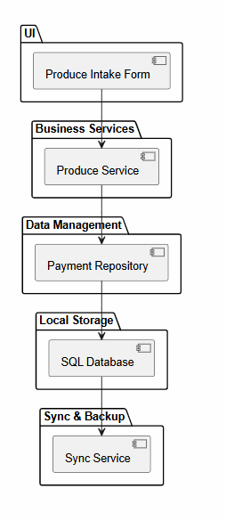
This package diagram shows the logical architecture of the system. It records the decision to use a layered structure that separates the user interface, business services, data management, storage, and synchronization responsibilities.

Deployment Diagram
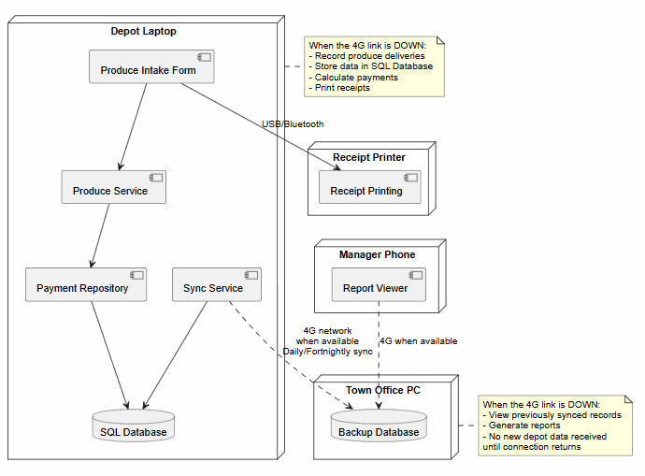
This deployment diagram shows how system components are distributed across physical devices. It records the decision to keep core processing and storage on the depot laptop so operations can continue during connectivity outages.

Use Case Diagram
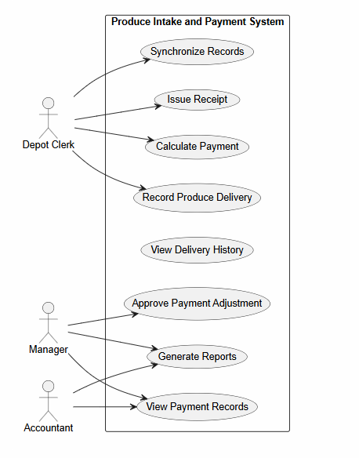
This case diagram shows the interactions between the Depot Clerk, Manager, Accountant, and the Produce Intake and Payment System. It records the decision to separate operational tasks such as recording deliveries from management functions such as report generation and payment approval.

Class Diagram
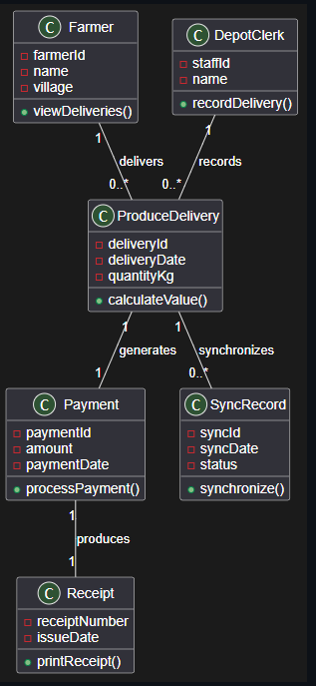

This class diagram shows the main entities involved in managing produce deliveries and payments. It records the decision that each produce delivery generates exactly one payment and that a farmer may have multiple deliveries over time.

State Diagram
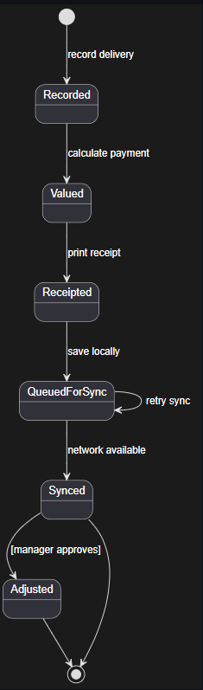
This state diagram shows the lifecycle of a produce delivery record from recording through synchronization. It records the decision that payment adjustments require manager approval before the record can move to the adjusted state.

Activity Diagram
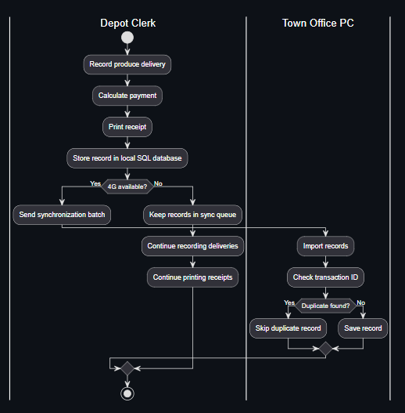

This activity diagram models the workflow for recording deliveries and synchronizing records. It records the decision to continue operating offline whenever the 4G network is unavailable.

Design Pattern: Repository Pattern
Where it Appears:
The Repository Pattern appears in the Payment Repository component located within the Data Management package of the system architecture. The Business Services layer accesses payment and delivery data through the Payment Repository rather than directly communicating with the SQL Database
What it Buys Us:
The Repository Pattern separates business logic from data storage logic. This makes the system easier to maintain, test, and modify because changes to the database can be made within the repository without affecting the Business Services layer. It also supports the system's offline-first design by providing a consistent way to access and store records before they are synchronized with the town office database.

AI Use Declaration
I used Microsoft 365 Copilot to assist with reviewing the Task 4 requirements, organizing the report structure, and verifying that all required components were included. All diagrams, design decisions, consistency checks, and final submitted content were reviewed and validated by me to ensure they accurately reflect my Software Requirements Specification (SRS) and project work.

